PMU Bus Booking System

Salahudean Tohmeh 201500027

Abdulaziz Khashogji 201500887

Abdullah Al-Qahtani 201201881

Musaad Al-Semari 201400956

Mohammed Al-Turki 201202187

Section 101 : Spring 2016/2017

GEIT 3351 -Principles of Software Engineering

The “PMU Bus Booking System”, or PMUBBS is a system which allows users to register accounts and/or login in order to reserve a bus ride from the school. It was developed with several contraints in mind; Saving time, easy to use and up to date. These 3 contraints made our team take some decisions which would simplify the use of the system.

The PMUBBS utilizes a Microsoft Access DB system in order to store its information about Users and Buses. We chose Access due to its great compatibility with Visual Studio and Visual Basic.

The program has 4 main “functions”; “Verify Username, Passwords and PMU IDs”, “Create new accounts and users”, “View available buses”, “Reserve buses”. These simplified functions make it easy for almost any user to use our program without much of a learning curve.

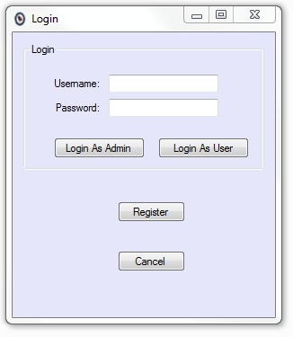

* Login Screen: The first window the user will see after opening the program. User has a choice based on if he/she has an existing account or not. If not, he/she can register and account.

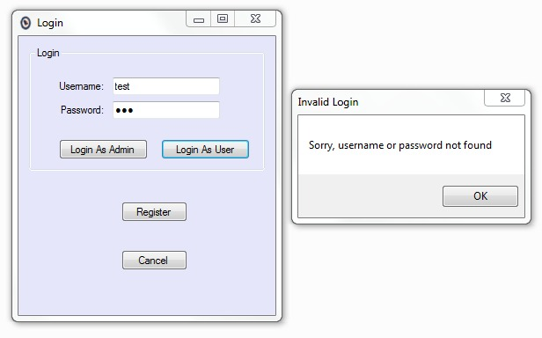

The system is able to produce windows which notify the user they have entered cannot be found in our database; suggesting that he/she should register first before trying to login.

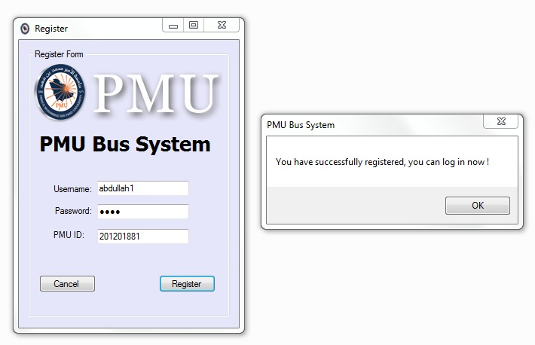

As can be observed, the system produces dialogs which notify the user if he/she have done everything correctly.

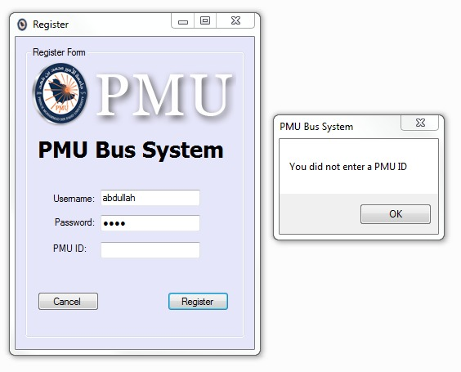

On the other hand, it notifies the user if he/she have done something wrong. In the screenshot attached above, the user failed to enter his PMU ID; he/she are notified and prompted to enter it again.

Finally, after any registering or logging in are done. The permitted user is able to access the list of users available to them.

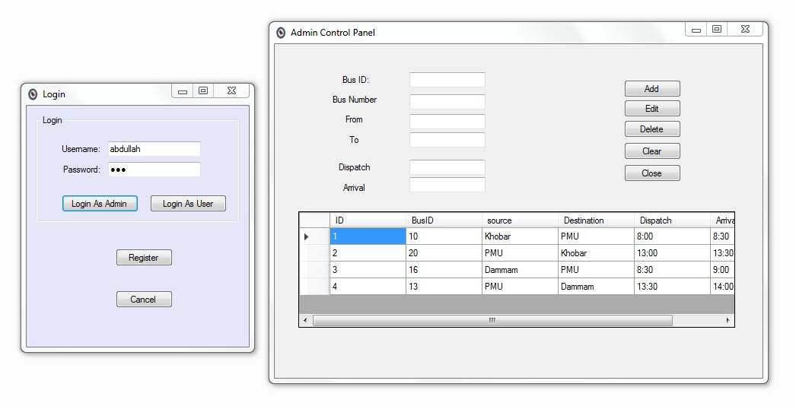

This is the Admin View, where he is able to view buses, but also able to add, delete and modify the buses. as can be seen, two windows are side by side. This makes the program easy to use for an admin when he wants to find out how the edits he makes show up for other users.

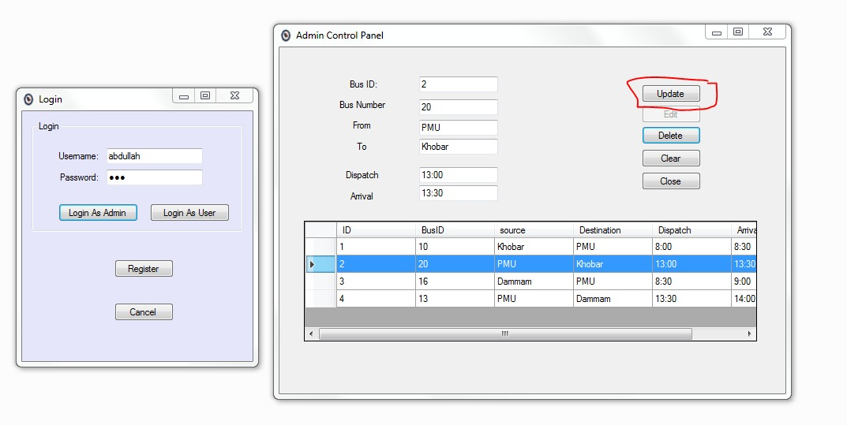

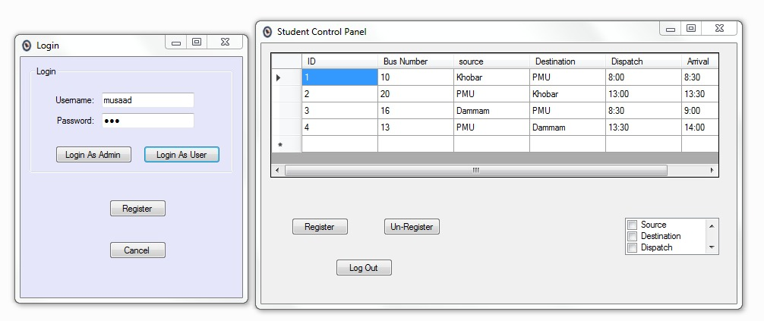

Here, the “User View” can be observed. Where the user can view various information about buses available to him. However, contrary to the Admin, he can only register or un-register from the available buses.

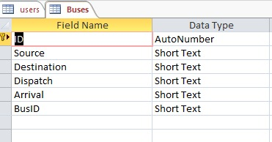

Here, we can observe the “Buses” schema in our MS Access DB with its many attributes.

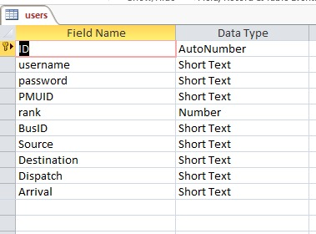

The “Users” schema can be observed in the MS Access DB with its many attributes.

The SCRUM Process was applied in order to make communication and keep track of progress. In the preperation phase, Abdulaziz was assgined the task of creating the different diagrams based on the brainstormed Ideas. As shown below, attached is the “Class Diagram” of the project.

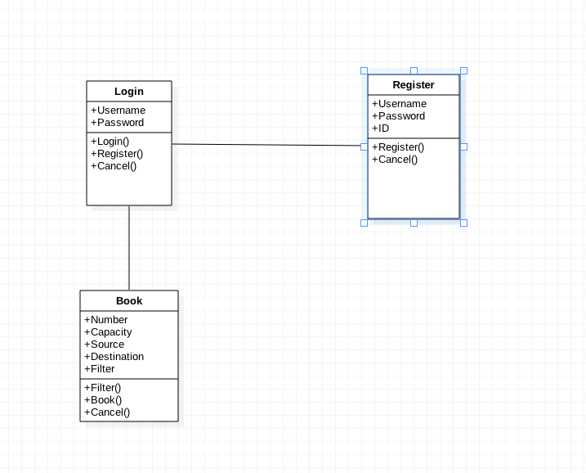

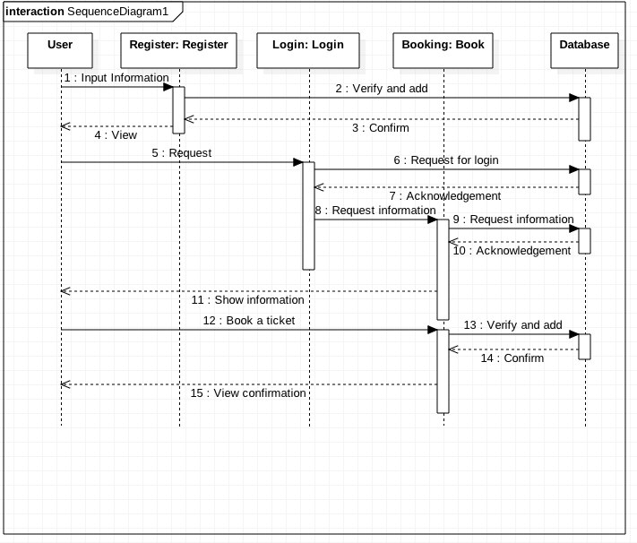Soon after we established the general structure of how the application would work and process different data, we assigned Abdulaziz the task of putting our ideas into a diagram called the “Sequence Diagram”, which is attached below for your amusement:

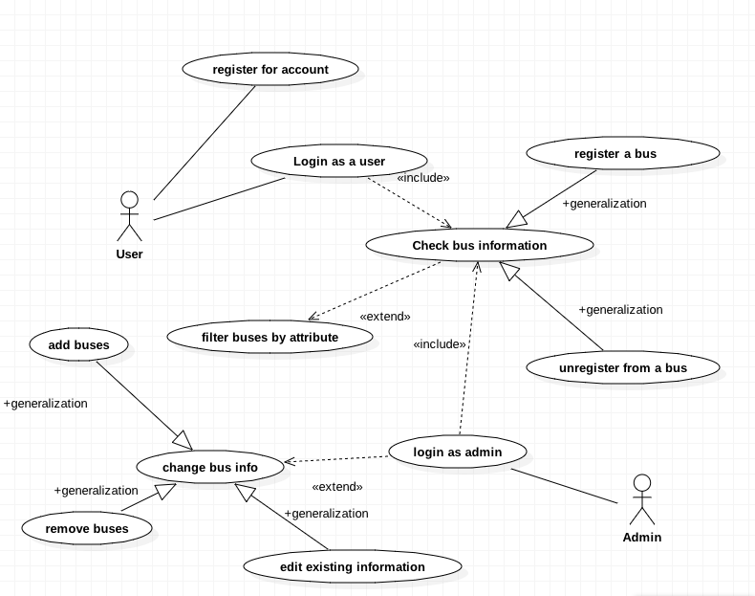

In this “Use Case Diagram”, The User can either register for an account if he/she do not already have on, or they can login; where they can check the bus information. There, they could either unregister if they are already registered or they could register if not. The user may filter the buses by several attributes such as by Source location or Dispatch time in order to make it easier to look at the information.

As for the admin, he/she are able to also view buses but they are also able to modify any attribute that is related to any given bus; such as removing, adding or editing already existing bus attributes.

Scrum Sprint Cycles:

|  |  |  |  |
| --- | --- | --- | --- |
| Team Members | Sprint | Time | Objectives |
| Mohammed Al-Turki  Abdulaziz Khashogji  Salahudean Tohmeh | Prep Phase | 6 Hours | Brainstorming System Architecture. |
| Abdulaziz Khashogji | 1st | 2 Hours | Create the Class Diagram |
| 1st | 4 Hours | Create the Sequence Diagram. |
| Salahudean Tohmeh  Mohammed Al-Turki  Abdulaziz Khashogji | 1st | 3 Hours | Design the System. |
| Abdullah Al-Qahtani  &  Musaad Al-Semari | 2nd | 5 Hours | Implement the “Login” Module |
| 3rd | 6 Hours | Implement the “Register” Module |
| 4th – 5th | 24 Hours | Implement the “Booking” Module |
| Abdullah Al-Qahtani | 5th | 2 Hours | Produce Screenshots of System. |
| Mohammed Al-Turki | 5th | 6 Hours | Create the Presentation. |
| Salahudean Tohmeh | 5th | 2 Hours | Create the Report. |
| Abdulaziz Khashogji | 5th | 1.5 Hours | Create the Use-Case Diagram |